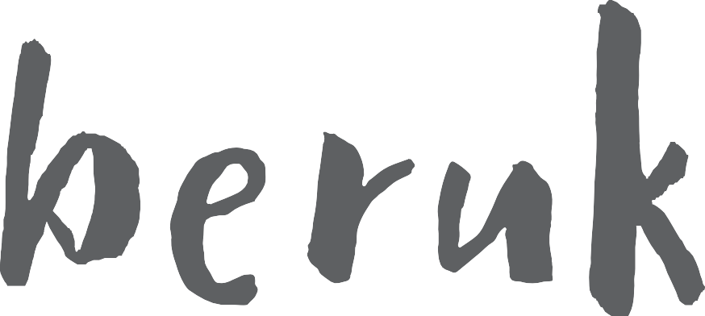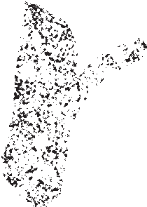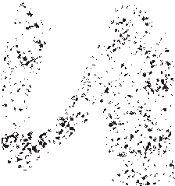

Beruk

To the colonial world he was William Barak, to his people he is Beruk. As Beruk’s descendants we present this exhibition in

his name, the name he was given at birth, spelt as it should be

pronounced.

Beruk (1824-1903), referred to as Ngurungaeta ‘Head Man’, or by settlers as ‘King William, last traditional chief of the Yarra Yarra

tribe’.

Beruk, named after the grub that lives in the Manna Gum tree, of the Wurundjeri people, the Woi-wurrung speaking custodians of the land we know as Melbourne and surrounds, whose Country lay along the Yarra and Plenty Rivers. Beruk was the son of Bebejern and great-nephew of tribal leaders Billibelleri, Captain Turnbull and Jakki Jakki who were signatories on the so-called Batman Treaty. Beruk witnessed his elders ‘mark’the Batman

treaty as a boy.

Until his passing, Beruk was the leader at Coranderrk and a fighter of rights and freedom for all displaced people and liaised between the protectorate and residents of Coranderrk Aboriginal

Station, Healesville.

Beruk balanced his culture and political actions while adapting to changing conditions in his own life. He was an accomplished painter, an activist, a diplomatic leader, and trailblazer for generations to come. He remains a source of knowledge for Wurundjeri people through his works and his influence expands

around the globe.

In this exhibition we welcome home two of his works, the painting Corroboree ‘Women in Possum Skin Cloaks’, and a Parrying Shield. These two works have returned and are now home where they belong, on Beruk’s home Country with his descendants

and community. We celebrate their return and accompany them with a story of the Beruk we know him to be, a leader, a son, a nephew, a husband, a father, grandfather, grand uncle, a friend

and a keeper of cultural knowledge.

The Beruk exhibition was created on behalf of Wurundjeri people and the community by the Wurundjeri Woi-wurrung Cultural Heritage Aboriginal

Corporation. It celebrates Wurundjeri Ancestor, artist, and traditional

Ngurungaeta Beruk’s life through painted and photographic portraits during the post-colonial era of the mission station.

Beruk’s cultural legacy is honoured here through the cultural objects he and other residents of the Coranderrk Aboriginal Reserve created. It is through

these gifts that all Wurundjeri people are reminded to be proud of their

identity, of their history, and the importance of keeping culture alive for future generations.

Cultural guidance by Wurundjeri Elders Karen Jones and Uncle Bill Nicholson Jnr. Curated by Stacie Piper in collaboration with Brooke Wandin, Mandy

Nicholson and Ashley Firebrace. This exhibition is presented by State Library Victoria through the Victorian Indigenous Research Centre with the support of

the Hansen Little Foundation.

Wall quote

*‘If a man was sensible and spoke straight, and did harm to no one, people would listen to him and obey him’*

*B**ERUK*

Traditional Leadership — Ngurungaeta

Cultural authority within the Wurundjeri tribe was given to those who earned the respect of their community by way of good character, knowledge, patience, inclusivity, and by elevating

the wants and needs of their people above their own. Beruk preserved and carried the culture of his people, at times and with certain individuals, even sharing some elements of traditional

leadership with non-Indigenous people.

Beruk explained, that a ‘Ngurungaeta is like a Governor’, 1 and

that, ‘if a man was sensible, spoke straight, and did harm to no one, people would listen to him and obey him.’ 2

Traditionally, the Ngurungaeta position would be inherited by a son from his father, although the son still had to prove his

suitability for the role. Age was not a defining factor in becoming a Ngurungaeta, instead, a good reputation, charismatic oration, and personal integrity meant that they would be considered

worthy of the role and win the support of other leaders.

Characteristically fair and sensible, while maintaining the respect and obedience of his people, the Ngurungaeta would be a man of great warrior ability, a renowned craftsman of cultural items

and maker of songs.

1

Barwick, ‘Mapping the Past: An Atlas of Victorian Clans 1835–1904 Part 1’, 108.

Howitt, *The Native Tribes of South-East Australia*, 307.

2

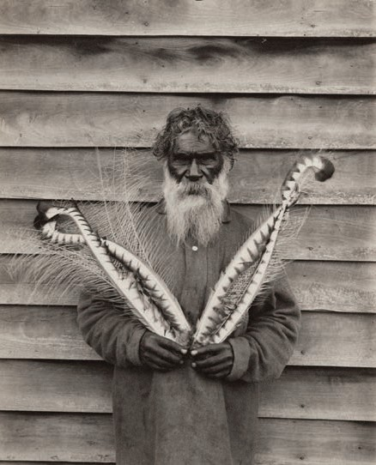

*In the image here, Beruk is holding up Lyrebird feathers.*

*The Lyrebird, a sacred spirit protector of the Wurundjeri – if you look carefully, you will see these feathers in many of Beruk’s ceremonial paintings. Traditionally used as a*

*headdress on both men and women, these captivating*

*feathers were worn in ceremonial dances called ‘Ngargee’. For the Wurundjeri, ceremonies would bring people together for a variety of important moments, such as family coming*

*together to celebrate or mourn, for tribal relationships, spiritual*

*responsibilities among many more.*

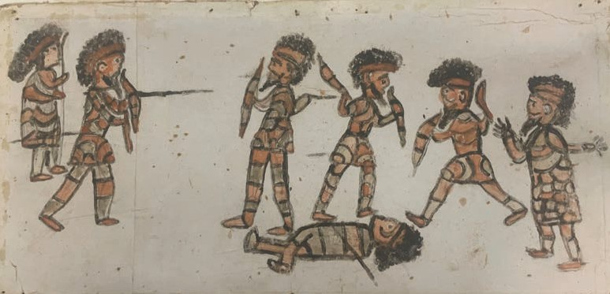

*Currently housed at the Melbourne Museum, on behalf of the Wurundjeri Woi-wurrung Cultural Heritage Aboriginal*

*Corporation, we see in this drawing Beruk’s use of cultural*

*tools and weapons for training, hunting, or in battle.*

Keeping culture alive

Wurundjeri people were denied using both their language and cultural practice while living on the Coranderrk Aboriginal Mission at Healesville. With no other safe place to go within the colony, Coranderrk’s mission managers also forced Christianity upon all the residents of Coranderrk. Despite these punitive measures, or the many other atrocities against Wurundjeri people at the time, Beruk remained a strong cultural man and never forgot his origins.

Being the intellect that he was, Beruk found inventive ways to keep his culture alive. When Coranderrk became a tourist

attraction for newly arrived settlers – due in part to the ingenuity and agricultural mastery of the Wurundjeri – Beruk saw his opportunity to protect and promote the Wurundjeri way of life,

inviting visitors and tourists to attend cultural displays.

The Aboriginal Protectorate were forced to accept this form of cultural practice for their own interests, but Beruk knew this was his chance to share his cultural knowledge with the younger generations out in the open, while also making and selling tools, artefacts, and artworks to sell to visitors — a win-win situation that brought money in to the community, while also being a

means to keep Culture alive.

Still seen as a great inspiration to the Wurundjeri community today, Beruk’s legacy continues to inspire the younger generations as they stand proud in their identity and keep their

Culture strong.

Maker of cultural items

In his later years at Coranderrk, Beruk made and sold handcrafted shields, paintings, and other cultural items that were used by the Wurundjeri people. He generously explained the use and technique of each object to visitors.

After meeting Beruk in 1892, Berlin-based ethnographer, Arthur Von Baessler, wrote that ‘not only was Beruk an author, but also a wood carver and painter. He completed for me a number of wooden fire-making implements, he also made boomerangs. His

pictures regularly illustrated Corroborees.’ 1

The skills needed to make certain objects were taught to Wurundjeri children from a young age and were important skills to learn to maintain the strength of the tribe. Wurundjeri Culture did not have a written form of communication, so instead,

information was conveyed through story, art, and ceremony

(song and dance).

The task of creating the objects of everyday life were generally shared between men and women. The women were experts

in weaving and crafting adornments, while the men trained in

woodworking and tool making.

Among the many differences between Wurundjeri and European cultures, were their reasons for war. In Wurundjeri Culture, wars were seldom fought over religion, resources, or land. Instead,

if the cultural lore was broken and clans or individuals felt that justice had not been served, there was the custom of payback battles, with punishments overseen by the Ngurungaeta who had

similar authority to that of a judge, as was given to him by his

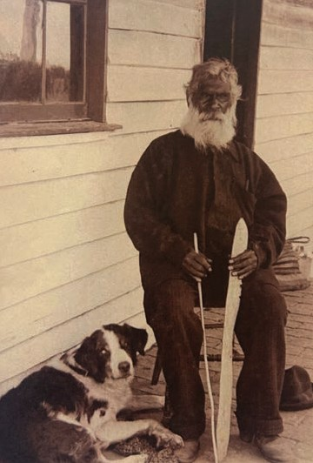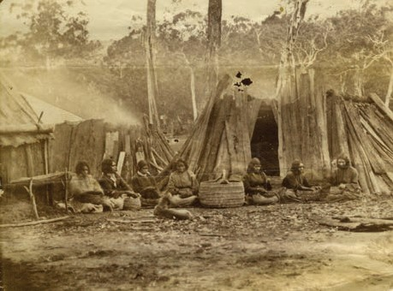

community. On display as part of this exhibition, Beruk’s *parrying shield* was used in hand-to-hand combat. Very rarely would

peoples’lives be taken in the process of war.

1

Clark, ‘*A Peep at the Blacks*’, 134.

*In this image, Beruk is sitting in a chair on his porch at Coranderrk with his beloved dog, holding two*

*of his hand made tools. These tools were used to make fire, by rubbing the stick into the base causing*

*friction and heat.*

*Image of women at Coranderrk weaving baskets, this process involved collection and*

*preparation of river reeds,*

*gathering and yarning whilst making.*

Wall quote

*‘You got to know your father’s country, Yarra is my father’s country.*

*Me no leave it, Yarra, my father’s country. There’s no mountains for me on the Murray.’*

*B**ERUK*

The emerging leader

Well known to possess all the qualities of a great Ngurungaeta, Beruk had leadership in his blood line, with his father Bebejan also an effective Ngurungaeta (clan leader) before him.

Considered a great storyteller, diplomat, tracker, and artist by those who knew him, Beruk had a generosity of character and

personal charisma:

*‘He possessed an intellectual head, covered with beautiful wavy hair, a kindly, intelligent face, with fine features,*

*and piercing black eyes. Barak was a man of remarkable personality, not tall, but erect. He carried him-self with regal dignity’1 Ann Bon*

*‘Although the Whites had robbed him of his land, he harboured no grudge against them; he was a good-natured guy with a strong character. Of all the blacks that I saw, he left behind with me the best impression.2*

*Arthur Von Baessler*

Held in the highest esteem by many notable non-Indigenous people, along with the decedents of those who lived at Coranderrk, Beruk is remembered as a cherished Ancestor,

inspirational leader, and keeper of Culture.

Beruk had become close to Sir Henry Loch, the Governor of Victoria from 1884. Loch regularly invited Barak to come to

Government House to meet important visitors.

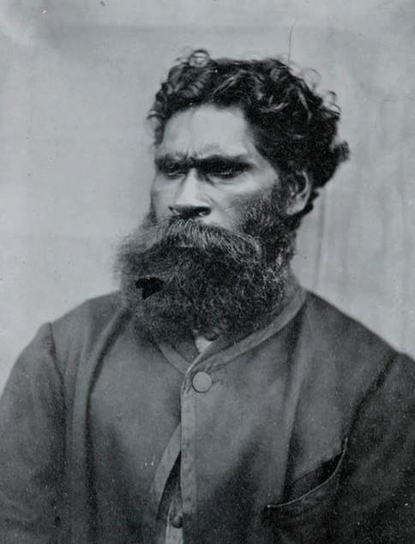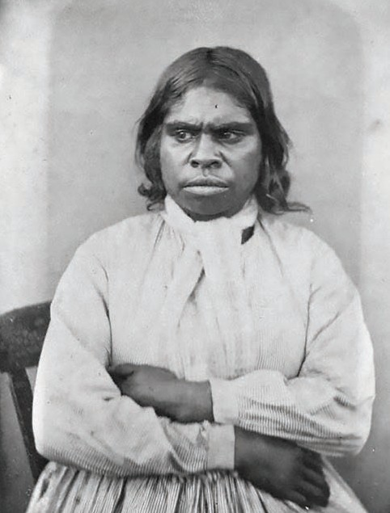

*The images here were portraits taken at the Coranderrk Aboriginal Mission. All who lived on the mission had their*

*portraits taken. Uncertain of their future, and missing their homelands, these would have been difficult photos for the*

*Wurundjeri to have had taken — as can be seen in the facial*

*expressions of our Ancestors.*

*The two inset are of Beruk at age 33 and his sister Boorat at*

*age 30. Beruk was also given the European name ‘William’and his sister Boorat was given the name ‘Annie’. Boorat is the*

*Ancestor from which all Wurundjeri people today descend.*

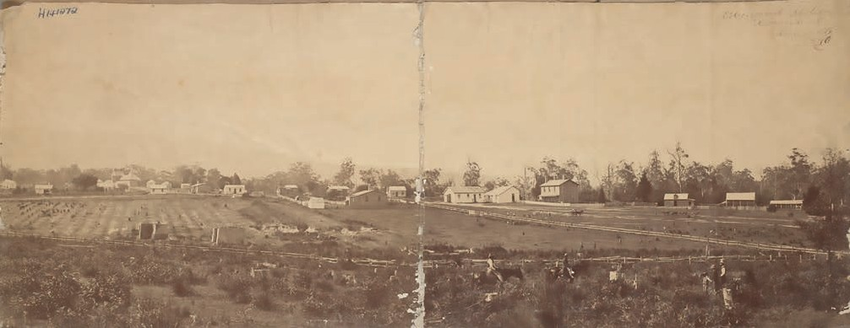

Coranderrk Mission

*Government: ‘Would you like the government to give you all the food you want, and all the clothing and no work?’*

*Beruk: ‘If they had everything right and the government leave us here, give us this ground and let us manage here and get all the money. Why do not the people do it themselves, do what they like and go on and do the work.’ 1*

Wonga and Beruk learned the old ways from their fathers, Billibileri and Bebejern. All were present at the signing of the so-called ‘Batman Treaty’. Grounded in ancient wisdom, both

Wonga and Barak would need to draw upon that strength for the

long battle ahead.

These men were the authority figures over the majority of the

Birrarung (Yarra) river catchment when Batman arrived.

Initially Wonga made requests for land, and along with John Green and Beruk, secured a site at the confluence of Badger Creek and the Birrarung. Coranderrk was gazetted June 30th

1863, and at the outset spanned 2300 acres. A place for mob to

stay connected to Country and each other. It became the site of

a sustained battle to seek and maintain autonomy.

Wonga and his younger cousin Beruk seized an opportunity by attending a public event in Melbourne honouring Queen Victoria’s birthday. Wonga delivered a speech in Woi-wurrung

and handcrafted gifts were presented to Prince Albert to pass on to the Queen. The intention was to confirm Coranderrk officially via a notice published in the Victorian Government Gazette the

following month.

Coranderrk grew in size and population, and became a place to regroup after decades of devastation and the impacts of colonisation. The adults adopted farming and the children

reading and writing, they never forgot their Aboriginal identities

and connections to their various Countries.

The Aboriginal Protection Act was passed in 1869, and gave extraordinary powers to the Board for the Protection of Aborigines, including regulation of residence, employment,

marriage and other aspects of daily life.

The Board despised Green’s management style, and in 1874, harassed Green until he in frustration resigned from his position at Coranderrk. Along with the death of Wonga in 1875, the residents of Coranderrk came together under Beruk, to continue the fight for Coranderrk and the reinstatement of ally John

Green.

In 1877 the first Royal Commission in the colony investigated treatment and conditions of Aboriginal people across the 6 missions in Victoria. The result recommended that reserves

should be maintained, under missionary supervision.

The resistance from Coranderrk continued, and when Graham Berry was elected in 1877, Beruk met with him to abolish the Board and allow the people to again manage Coranderrk

alongside Green.

In 1881 a Parliamentary Inquiry took place over two months. The focus was the management of Coranderrk. Seventeen men, four women and one young boy gave evidence, and importantly they presented a united front. Their collective demand did not waiver, their final petition stated they wanted self-governance and

autonomy.

Beruk continued his diplomacy by walking to Melbourne to meet government officials to urge the implementation of the recommendations of the Inquiry. Berry eventually ordered that

Coranderrk be permanently reserved as a site for the use of the

Aborigines in 1884.

This did not stop the protection board who would never let

Aboriginal people get one over them.

Beruk petitioned the government again, this time concerning the exerted pressure of the Protection Board to sell off Coranderrk

and to kill off Coranderrk and to shut Beruk down.

Legislation was again to cause chaos for the residents of Coranderrk. The *Aboriginal Protection Law Amendment Act* passed in 1886, defined what it meant to be Aboriginal. This racist policy conceived the idea of the ‘half-caste’and decimated the population at Coranderrk. Some elderly residents refused to

leave.

The Coranderrk Lands Bill was passed in 1948 revoking the remaining land and making it available for soldier resettlement;

no Aboriginal people are eligible for the land.

Beruk produced paintings later in life at Coranderrk. He joined his ancestors in 1903. Beruk’s works offer insight into his recollections of his early life, repositories of precious cultural knowledge. Wurundjeri people look up to Beruk as a great

inspiration and his spirit and legacy live on to this day.

*‘We should be free like the White Population there is only few Blacks now rem[a]ining in Victoria, we are all dying away now, and we Blacks of Aboriginal Blood, wish to have now*

*freedom for all our lifetime . . . Why does the Board seek in these latter days more stronger authority over us Aborigines*

*than it has yet been?’ 2*

1

John Ferres Government Printer Melbourne, ‘CORANDERRK ABORIGINAL STATION. Report of the Board Appointed to Enquire into, and Report upon, the Present Conditions and Management of the Coranderrk Aboriginal Station, Together with the Minutes of Evidence’,9, 10.

National Centre of Biography ANU, ‘Coranderrk Station (Vic) — Obituaries Australia’.

2

Wall quote

*‘We should be free like the white population there is only few blacks now remaining in Victoria, we are all dying away now, and we blacks of Aboriginal blood, wish to have now freedom for all our lifetime.’*

*B**ERUK*

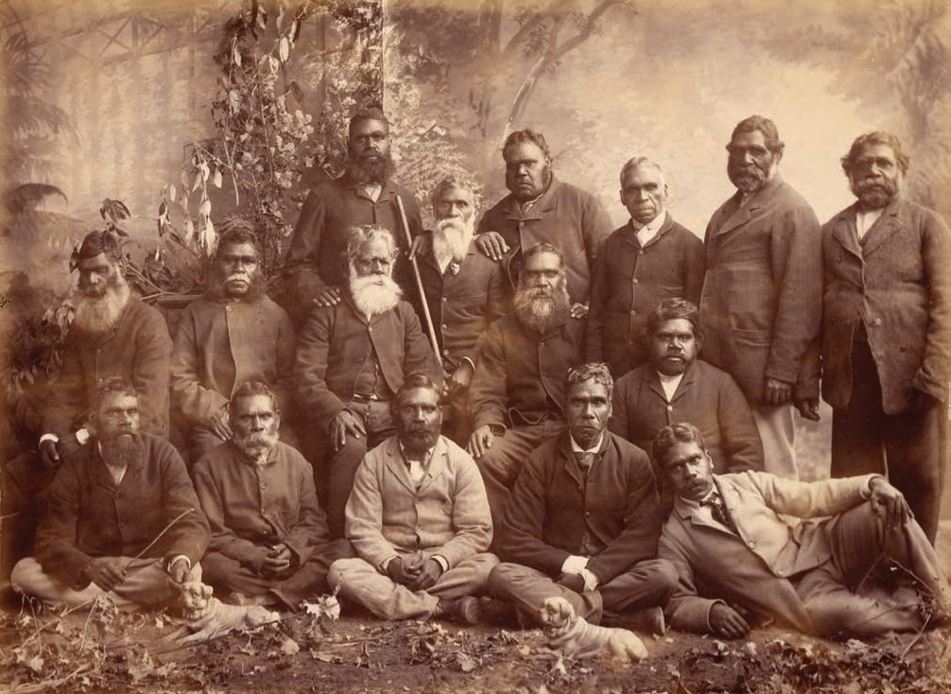

*This image is of a group of men who were on a deputation with*

*Beruk to Melbourne in 1886.*

Diplomatic resistance

Beruk was the most influential Aboriginal leader of his time.

Following on from his cousin and Wurundjeri Ngurungaeta, Simon Wonga, Beruk launched an unwavering political campaign to have the voices of the people at Coranderrk heard. Beruk

led ten deputations, travelling from Coranderrk to Parliament House on foot, to have the demands of his people heard by the colonial authorities. Known for his diplomatic skills, Beruk enlisted the support of his influential and politically connected

non-Indigenous friends in the fight for his people.

Beruk collaborated with his lifelong friend and landholder Ann Fraser Bonn, and radical Premier Graham Berry, who was the first to facilitate a hearing of the concerns of Coranderrk residents before the Central Board for the Protection of Aborigines. Beruk was seeking the independent management

of Coranderrk away from the Central Board and its oppressive

control. 1

Determined to provide a place of independence and opportunity for his people, and for them to stay on Country, Beruk shared the

following:

*‘You got to know your father’s Country, Yarra is my father’s Country.*

*Me no leave it, Yarra, my father’s Country. There’s no*

*mountains for me on the Murray.’*

*Beruk*

*2*

Capturing the depth of his relationship to and responsibility for Country, Beruk’s words still resonate with Wurundjeri

descendants today.

1

Nanni and James, *Coranderrk: We Will Show the Country*, 203.

Ryan, Cooper, and Wandin-Murphy, *Remembering Barak*, 4.

2

Songlines and memory

Songs sung by Beruk and his Ancestors before him were full of meaning and Culture and told the stories of their lands and people.

Sung by individuals, accompanied by dance, or performed by many as part of grand ceremonies, songs held memories, histories, and knowledge within their words, rhythms, and

melodies. This was a traditional way of sharing information within

the tribes.

Beruk recalled that songs had been handed down from long ago, saying that he ‘heard it from the old people his grandfather and mother’s brother, who said they got it from their parents who got

it from theirs, who got it from Bunjil’. 1

Beruk also tells of his great uncle, the great song-man Ningalabul of the Gunung Willum Balluk of the Woi-wurrung language group. Ningalabul came from a long line of distinguished orators and was an influential Ngurungaeta whose vast knowledge of songs and masterful compositions gave him

great authority.

Beruk sung some of Ningalabul’s songs for anthologist Alfred Howitt and in recalling the power of Ningalabul’s songs, said that

they ‘made men sad and joyful when they heard them’. 2

Howitt also noted that Beruk was moved to tears as he sang. 3

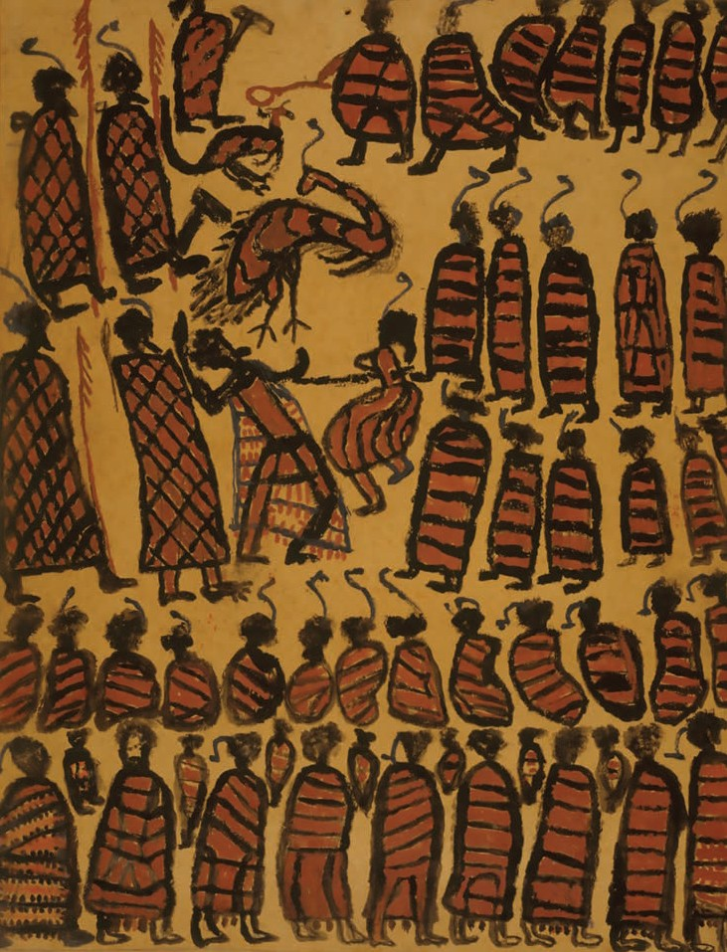

*Painted by Beruk, this image depicts Wurundjeri Ceremony.*

*Song and dance played a significant part of all important ceremonial practices.*

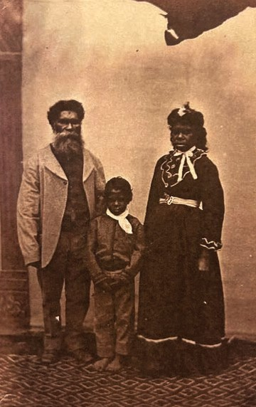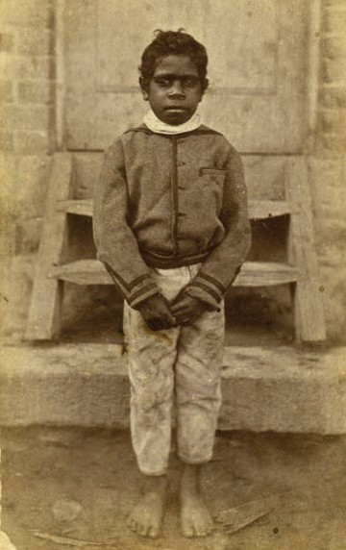

*The images are a family portrait of Beruk, wife Annie and son*

*David, and a standing portrait of his son David.*

Older leader

Beruk’s later life was tainted with sadness. In 1881, Beruk’s only son David, heir to the Ngurungaeta, became gravely unwell.

Determined to save his son, Beruk set out on foot and carried David, aged only 10, from Coranderrk, Healesville to Kew

Hospital.

As an Aboriginal man, Beruk was not permitted to stay by David’s side in the hospital. David later died, alone and without family by his side. Beruk’s wife, Annie, died shortly after this.

Sadly, Beruk’s direct lineage also died with David.

Throughout Beruk’s life he worked hard to accommodate the white man in the hope that they would support his people and

see their common humanity. Following the colonial invasion

of the Kulin lands, many Aboriginal people were displaced

from their homelands and came to live at Coranderrk. Beruk advocated for the welfare and rights of all who lived at Coranderrk, and collaborated widely with the many Kulin leaders and advocates that sought refuge on his Country.

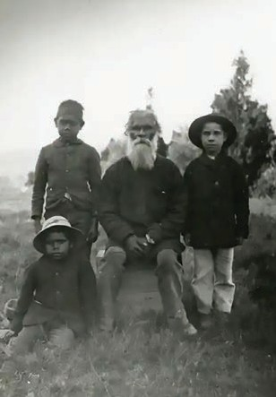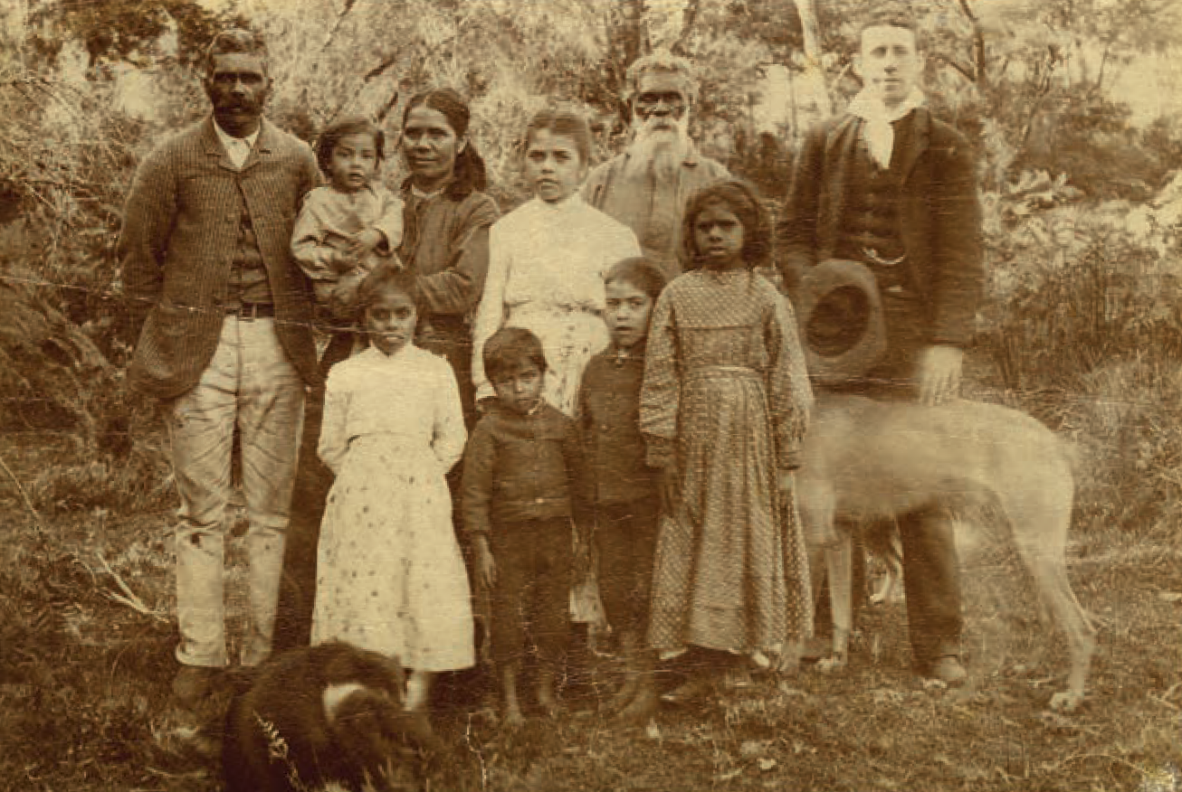

*Image of Beruk with children who looked up to him as a Lalal.*

Rememberance of a Lalal, Grandfather,

Grand Uncle

*‘Lalal, that’s King Barak, that’s our Lalal, grandfather in the black style, grand uncle in the white style’*

*Uncle Frank Wandin*

*‘Lalal, he would be a grand uncle to us, he was my father’s uncle’*

*Aunty Martha Nevin*

The traditional kinship system of the Wurundjeri Woi-wurrung

people was a great strength in tribal society.

Kinship meant that all the children had many Elders to learn

from, guiding them in the skills they needed to contribute to the community and be a part of society.

Uncle Frank Wandin remembers days spent with Beruk, and him

saying:

*‘All us boys. All of us the Wandin’s and Lalal. That’s when we’d talk to him Saturday morning sometimes – he’d ask what do you boys want to do, laughs, and had get up on his chair and get his tommy hawk, then we’d go out and he would show us things in the bush.’*

*Uncle Frank Wandin*

This traditional approach to teaching and learning Culture, continued throughout Beruk’s lifetime, and his great knowledge and staunch leadership meant that he was loved and respected

far beyond his Woi-wurrung kinspeople and descendants.

Wall label

*Barak: last chief of the Yarra Yarra Tribe of Aborigines*

1885

Florence Ada Fuller

Oil on academy board

H24629, Gift of Anne Fraser Bon, 1901

Wall quote

*‘Once my people were as many as the leaves of the gum trees, but now only old man left. Soon the white man can have it all.*

*Old man going away when the wattles bloom. My father died when wattles came, and I go too.’*

*B**ERUK*

Case label

Beruk

*Corroboree*

c. 1900

Wurundjeri

Charcoal and ochre on paper

Courtesy of the Wurundjeri Woi-wurrung Cultural Heritage Aboriginal Corporation

*Women in Possum Skin Cloaks.*

Wall label

*King Barak, last of the Yarra Tribe*

1899

Victor de Pury

Oil on canvas

On loan from private collection

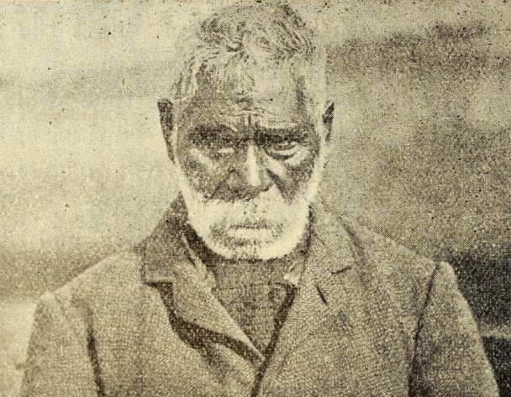

*This image is the last photo of Beruk, he outlived most of his*

*family and to an age that was not common at that time. He had suffered many broken promises, and saw much suffering over his lifetime but his dignity and intelligence remained intact.*

Remembrance of an artist, activist, and diplomat

Beruk’s artworks are a gift to his descendants and anyone who respects the oldest living culture on earth. Through his art, Beruk recorded and continued Wurundjeri Culture for the generations to come.

There are many ways that Beruk recorded his culture, preserving it for his descendants. Beruk’s paintings and words bring to

life his memories of cultural days. In 1882, Beruk directed an attendee of the Coranderrk School to write down ‘My Words’. 1 Remembering the arrival of white men to Kulin Country, Beruk describes that he was 11-years-old when John Batman first visited Port Phillip in 1835. 2 In this account, Beruk remembers

the warning and advice given by escaped convict William

Buckley to the Kulin peoples. Buckley’s years living with the Kulin had made him fluent in the language and Culture. Buckley offered the Kulin ways to engage with the newly arrived people

saying:

*‘any white man that you see in the bush not to touch him, when you see empty hut not to touch the bread. Make a camp outside and wait till the man comes home, when the man comes home and finds everything safe in the house,*

*they are good people. If you kill one white man they will*

*shoot you down like Kangaroo’.*

*3*

Berak goes on to say that, ‘a lot of white fellows come here by

and by and clear the scrub all over Country.’ 4

Berak’s memories of pre-Coranderrk days give us a glimpse into the cultural life he lived and his experience of the devastating

colonial invasion.

1

‘MY WORDS.’ ‘MY WORDS.’ ‘MY WORDS.’

‘MY WORDS.’

2

3

4

This map illustrates the vast distances Uncle’s items travelled around the world, with some returning back to Country. These immense distances reflect the scope of his influence and legacy,

both for his descendants and for the many who came within his sphere.

The work is surrounded in paint made from earth pigments collected at Coranderrk Aboriginal Station where his paintings

were created. The title and intentions of this map converge with this physical presence to embody Country.

Uncle’s paintings are not objects, they are physical manifestations of his spirit and his ways of knowing. Together with the many cultural items held in various institutions around the world, including remains of Ancestors, language material and other significant works, these are not ‘things’, they are the

lifeblood of culture and community.

One hundred and twenty years after his passing these items are precious sources of information. Wurundjeri descendants now have access to and can provide direction around care, interpretation and representation of these irreplaceable cultural

repositories.

Uncle, bringing Country into these representations is another way of bringing them back home, this is my gift to you Lalal.

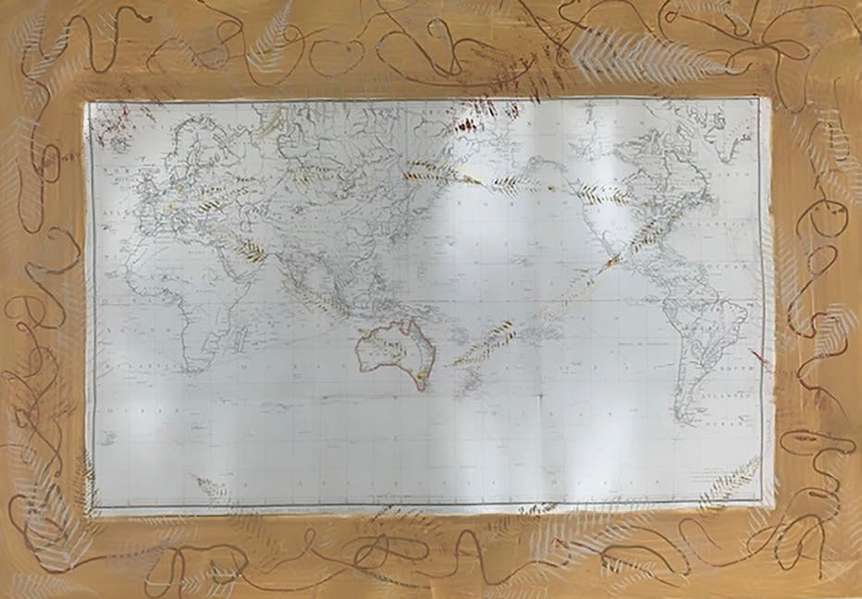

*beruk mangmangnjan — I remember Beruk Brooke Wandin*

1185mm x 840mm

paper, earth pigment, acacia gum, hemp cord, cotton twine, gold and silver marker

*Argus.* ‘MY WORDS.’12 December 1931.

[http://nla.gov.au/nla.news-article4407599.](http://nla.gov.au/nla.news-article4407599)

Barwick, Diane E. ‘Mapping the Past: An Atlas of Victorian Clans 1835–1904 Part 1’. *Aboriginal History Journal 8* (1984): 100–131.

Clark, Ian. *A Peep at the Blacks’* : A History of Tourism at Coranderrk

Aboriginal Station, 1863-1924. Warsaw: De Gruyter Open Poland, 2015.

Howitt, A. W. *The Native Tribes of South-East Australia*. Macmillan and Company, limited, 1904. https://doi.org/10.2307/2787604.

Howitt, Alfred, and William Barak. ‘“Notes by Howitt on Kulin from Barak”, Ms 9354 Box 1053/2(b)d(c), State Library of Victoria; “Notes by Howitt on Kulin

from Barak”, From the Page, HW0391’, n.d.

Howitt, Alfred William. *Notes on Songs and Song Makers of Some Australian Tribes*. Harrison and Sons, 1887.

John Ferres Government Printer Melbourne. ‘CORANDERK ABORIGINAL STATION. Report of the Board Appointed to Enquire into, and Report upon,

the Present Conditions and Managment of the Coranderrk Aboriginal Station, Together with the Minutes of Evidence’. Royal Commission. Melbourne, n.d.

Nanni, Giordano, and Andrea James. Coranderrk: *We Will Show the Country*. Canberra: Aboriginal Studies Press, 2014.

National Centre of Biography ANU. ‘Coranderrk Station (Vic) - Obituaries Australia’. Accessed 27 October 2023.

https://oa.anu.edu.au/entity/14880/text35596.

Ryan, Judith, Carol Cooper, and Joy Wandin-Murphy. *Remembering Barak*. Melbourne: National Gallery of Victoria, 2003.

Victorian Collection. ‘Life of Barak’. Victorian Collections. Accessed 27

October 2023. https://victoriancollections.net.au/stories/william-barak/life-of- barak.

Case labels

Beruk

*Boomerang*

1890

Coranderrk, Port Philip, Victoria, Australia Wood

X 105350, on loan from Museums Victoria

*Used for hunting and digging for food, a weapon, ceremony.*

*Lyrebird feather*

2021

Collected on Wurundjeri High Country from the forest floor Courtesy of Stacie Piper

*These were worn by women and men in Ceremony as depicted in many of Beruk’s paintings.*

Maker once known

*Wit wit | Throwing stick*

1867-1903

Coranderrk, Port Philip, Victoria, Australia Plant fibre and root

X 44761, on loan from Museums Victoria

*Used in traditional games and play.*

Beruk

*Woomera | Spearthrower*

pre 1903

Coranderrk, Port Philip, Victoria, Australia X 080471, on loan from Museums Victoria

*Used to enhance the force of a spear in hunting.*

Case label

Beruk

*Parrying shield*

c. 1900

Wurundjeri Wood, ochre

Courtesy of the Wurundjeri Woi-wurrung Cultural Heritage Aboriginal Corporation

*Shields were used for hunting and combat.*

Case labels

*Wulunj | Kannak | Digging stick*

2018

Arika Waulu

Wurundjeri Wood

Courtesy of Stacie Piper

*Used to dig for murnong tubers, hunting and gathering food.*

*Lyrebird feather*

2021

Collected on Wurundjeri High Country from the forest floor Courtesy of Stacie Piper

*These were worn by women and men in Ceremony as depicted in many of Beruk’s paintings.*

*Possum skin, Dancer skirt*

2018

Mandy Nicholson

Wurundjeri

Possum skin, waxed string, pyrography Courtesy of the maker

*The possum skirts are made and worn by each dancer, their totem and stories burnt into the skin side. These are worn for dance and ceremony; they can also be wrapped around the shoulders. The*

*design burnt into this skirt is the Djeri, the grub, to honour Beruk and the Wurundjeri people.*

*Reed necklace*

2018

Djirri Djirri Collective

Wurundjeri

Dried river reeds

Courtesy of Stacie Piper

*These are made and worn around the neck.*

*narragout mundagat – shields protect*

2020

Brooke Wandin

Wurundjeri Raffia

Courtesy of the maker

*ʻOne of a set of 3 woven shields, created as a way to protect myself*

*ngulla ba mungeit, ngulla ba nuringian*

*marnangik berren berren, durndurnik wonthaggarook ngalimbe ba mungeit, ngulla ba nuringian*

*narrkwarrenik mangmangnhan*

*ngulla ba mungeit, ngulla ba nuringian narrangout mundagat*

*Sit and make, sit and think Hands busy, my mind quiet Sit and make, sit and think Thinking about my family Sit and make, sit and think Shields to protect me’*