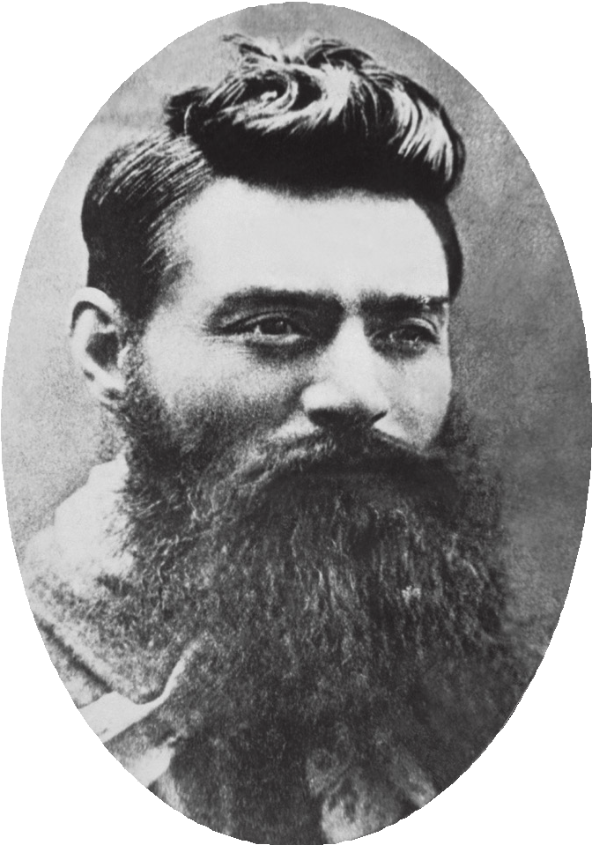

**NED KELLY**

Redmond Barry Reading Room

**Ned Kelly**

Edward ‘Ned’ Kelly was Victoria’s most infamous

bushranger. He led a group of outlaws known as the Kelly gang in the late 1870s. For 18 months, while on the run

from police, they robbed banks, took hostages, chopped down telegraph poles and destroyed part of a railway line. Although finally hanged for fatally shooting three

policeman, Kelly’s life and actions have been the subject of debate for more than a century. At the time of his trial, one fifth of Melbourne’s population signed a petition

against his execution. Today the question of whether

Kelly was a criminal, or a hero is still debated.

Kelly argued that there were important personal and political reasons behind the gang’s actions in a 56-page statement, now known as the Jerilderie Letter. Kelly dictated the letter to gang member Joe Byrne, claiming that he shot the police in self-defence. He also describes how he and his family,

poor Irish farmers, were the victims of racial and class-based persecution at the hands of the police and the ‘squattocracy’ who controlled the most fertile farming land and parts of the

government.

The Library is home to a variety of objects relating to Ned Kelly, along with the armour displayed here. We care for the Jerilderie Letter, as well as the archival materials for Australian author Peter Carey’s novel True History of the Kelly Gang (2000). The Jerilderie Letter, which Carey

describes as a ‘howl of pain’, is inscribed with ringing

phrases but also violence. Although its full contents weren’t made public until the 1930s, Kelly’s words have endured and been adopted by various groups who have mobilised Kelly

and his story for their own ends.

Soon after Kelly was hanged at Melbourne Gaol on 11 November 1880, a ‘Kelly culture’ emerged. Kelly’s own family spoke publicly about Ned, and there are many films, books, poems, songs, plays and a ballet that draw on his life, as well as the iconic paintings by Australian artist Sidney

Nolan. At the opening ceremony of the 2000 Sydney Olympic Games, Ned Kelly was part of how Australia told its national

story to the world.

Image above:

Charles Nettleton

**Ned Kelly the day before he was hanged 1880**

photographic print, (toned) 1880 Find in the catalogue: H18202

**The Trial**

A jury found Ned Kelly guilty of Constable Thomas

Lonigan’s murder, and a death sentence was handed

down by Justice Redmond Barry. The trial was depicted in a wood engraving in the Illustrated Australian News, reproduced here as a backdrop to Kelly’s armour. Kelly stands in the dock while Barry oversees the case from

the bench, wearing the wig and robes of the British legal system. The trial took place at the Central Criminal Court

on Russell Street, across the road from the Library.

This type of engraving was common in 19th century publications. As there is no official transcript of the Kelly trial, knowledge of the proceedings comes from journalists who reported on the two-day event. The press played an important role throughout the gang’s evasion of the police and Ned Kelly’s trial, communicating information and

shaping public opinion.

After 25 minutes of deliberation, Barry delivered the jury’s verdict and his sentence. Kelly declared his mind to be easy and clear, causing a sensation in the crowded courtroom.

Kelly, who was advised by his lawyers not to testify, said that he expected the result, but had he addressed the witnesses himself he could have cleared his name. In a potent exchange with Barry, Kelly repeats the phrase, ‘no one understands my case as I do,’ and his last words to the judge were, ‘I will see you there, where I go.’ In a very

different way than what Kelly may have intended, the two

men are now reunited through their connection with the Library: Barry as co-founder of the Library and namesake of this reading room, and Kelly as one of the most infamous figures represented in our collections. You will find a portrait

of Redmond Barry at the opposite end of this reading room.

Image left:

James Waltham Curtis

David Syme and Co. Publisher, Melbourne

**A Strange Apparition - Ned Kelly’s Fight and Capture**

wood engraving, July 17, 1880

Find in catalogue: IAN17/07/80/120

**The Armour**

Ned Kelly’s iron armour is a defining part of his story. Details on where, why, and how it was worn, as well as its improvised design, have helped to ensure its iconic

cultural status. All four members of the Kelly gang – Ned, his brother Dan, and their friends Joe Byrne and Steve Hart – wore armoured suits in their final confrontation with the police at Glenrowan in June 1880. Under his armour

Ned Kelly wore the green silk sash awarded to him as a

child for rescuing a younger boy from drowning.

The Age reported that as bullets hit Kelly’s armour he always recovered, and ‘appeared as if he were a fiend with a charmed life.’ Eventually, police shots to his legs brought Kelly down in the bush behind the Glenrowan Inn. He was

the only gang member to survive the siege.

The armour is constructed from farm machinery. Historians have speculated that the parts may have been stolen or gifted, and that the armour was forged by blacksmiths who may have been sympathetic to the gang. But these ideas

remain unconfirmed.

While Ned Kelly’s armour was in the care of The Institute of Applied Sciences, now part of Museums Victoria, an assistant director there asked, ‘Why should we revere a convicted murderer?’ and so in 1965 the armour was taken

off view and transferred to the care of the Library.

That question frames a debate now more than 100 years old. After all this time, it continues to describe the unsettled complexity of this story. The Library is one custodian of Victoria’s memory and somewhere to debate what, how and why we tell stories about our past and how we remember

ourselves to the future.

Main image:

David Syme and Co. Publisher, Melbourne

**The Kelly Trial - The Scene in Court (detail)**

wood engraving, November 6, 1880 Find in catalogue: IAN06/11/80/201

Discover the full extent of State Library Victoria’s Kelly collection by searching the catalogue, and learn

more about Ned Kelly on our website:

<https://www.slv.vic.gov.au/ned-kelly>

RSAF Enfield – Manufacturer

**Snider-Enfield 0.577 calibre long rifle belonging to Ned Kelly before 1880**

Metal and wood / H2002.136 Anonymous donation 2001

This rifle butt contains several inscriptions, but the clearest is ‘NK son of RED’. Ned Kelly’s father, whose name was John, was known as Red Kelly. The second inscription, on the le -hand side of the butt, is of a deer with the letter K and the number 8 (K 8) underneath, and below that a heart shape with the letters U and R inside it. This cryptogram, or coded text, reads: Dear / Kate / you are / in my heart. It is now acknowledged that Ned’s sweetheart was Kate Lloyd, daughter of Tom Lloyd. Tom Lloyd was first cousin to Ned and Dan Kelly, the so-called fi h member of the Kelly gang. This rifle was once in the possession of the

artist Albert Tucker.

Unknown maker

**Boot worn by Ned Kelly c.1870-80**

Leather, iron and wood

On loan from the descendants of the late Jesse Dowsett

This boot, belonging to Ned Kelly and worn during the last stand at Glenrowan, was awarded to Jesse Dowsett for his role in Kelly’s capture. Dowsett was railway guard of the special train

that took police to the siege site.

Unknown maker

**Armour worn by Ned Kelly at the siege of Glenrowan on 28 June 1880**

Steel, 44kg / H20171

Right shoulder plate purchased by State Library Victoria with funds from the Sundberg Bequest and the Department of

Communications, Information Technology and the Arts in 2001.

Le

shoulder plate on loan from Museums Victoria. Curator

Allison Holland researched the history of the Kelly gang armour in 2001. Examining photographic evidence and the results of material analysis, she discovered that the set held by the Library and believed to be Steve Hart’s was, in fact, Ned Kelly’s. The lappet, or metal apron, of this suit has not been authenticated,

but was fitted to the breastplate some time before 1894.